Information Visualization Project

**Spring 2019**

**ITCS 5122 - Visual analytics**

Hemantha Krishna Chandra Sekhar Chundi

Jarvis Dao

Shubham Bose

**OVERVIEW**

Taxi trajectory data records real-time moving paths sampled as a series of positions associated with vehicle attributes over urban road networks.

**GOALS**

To implement a visual analytic system for taxi trajectory data that support data exploration and analytical reasoning with interactive visual interfaces. The system should help the user to conduct visual analytics tasks through interactive visualization in an iterative, exploratory process.

**SPECIFICATIONS**

**Task 2:** We implemented the top pick-up and drop-off street names with its relation by usingan Interactive Chord Diagram or Sankey Diagram.

**Task 3:** We show the most frequent street names using an Interactive Word Cloud.

**Task 4:** We provide an interactive Scatter-Matrix to show the relationship between differentattribu

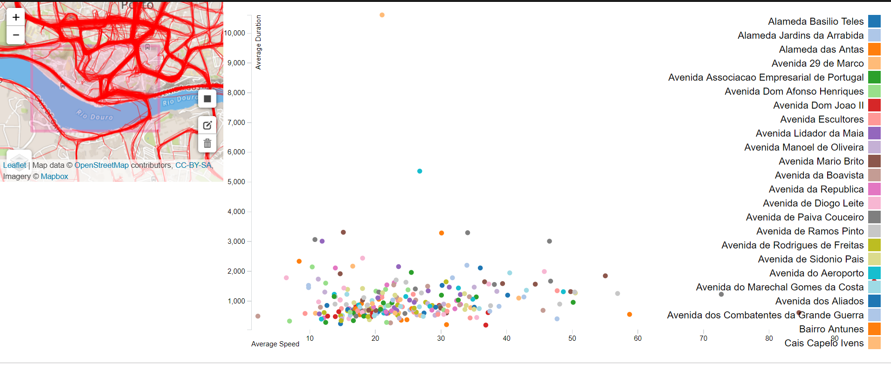 *Screenshot - 1*

Screenshot – 2

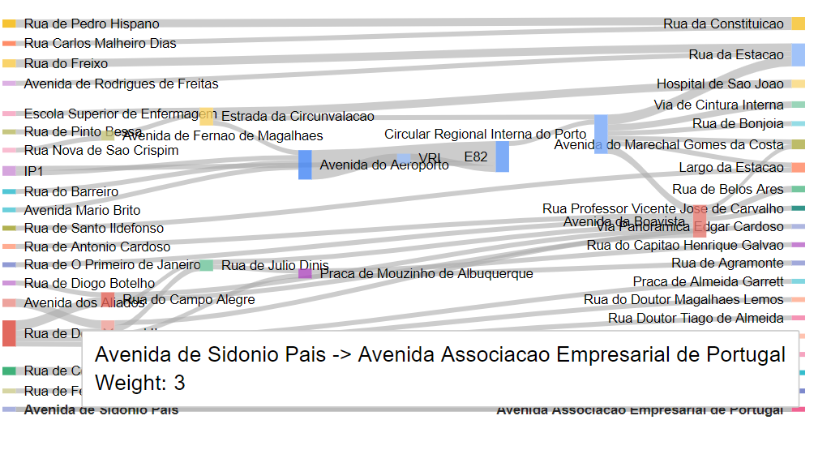

Screenshot - 3